**Chapter 4: DESIGN AND ARCHITECTURE**

**4.1. Introduction**

Designing an Android project requires careful planning and attention to detail. The first step in the process is to identify the problem that the app will solve and the target audience. This information will help to determine the app's features and functionality. The next step is to create wireframes and prototypes of the app, which will serve as the visual representation of the app's layout and user interface. The app's design should be user-friendly, intuitive, and aesthetically pleasing. Color schemes, fonts, and icons should be carefully chosen to create a cohesive and visually appealing app. It's also essential to consider accessibility and ensure that the app is usable for users with disabilities. Finally, testing and feedback from users will help to refine and improve the app's design before its release.

Design is the first step in development phase for any techniques and principles for the purpose of defining a device, a process or system in sufficient detail to permit its physical realization. On the software requirement have been analyzed and specified the software design involves three technical activities- Design, Coding, Implementation, Testing that are required to build and verify the software The design activities are of main importance in this phase, because in this activities decisions ultimately affecting the success of the software implementation and its ease of maintenance are made. These decision has the final bearing upon reliability and maintainability of the a system. Design is only way to accurately transfer the customers requirements into finished software or system Design is the place where quality is fostered in development. Software design is the process through which requirements are translated into 2 representation of software. Software requirement is conducted in two steps Preliminary design is concerned with the transformation of requirements into data.

**4.2. USE CASE DIAGRAM**

**1. Login Page**

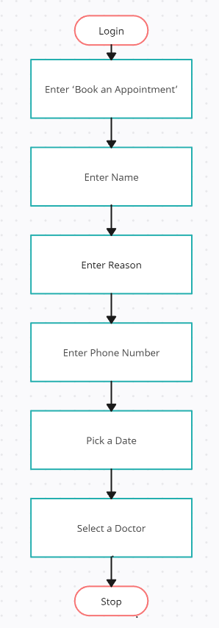

**2. Register Page**

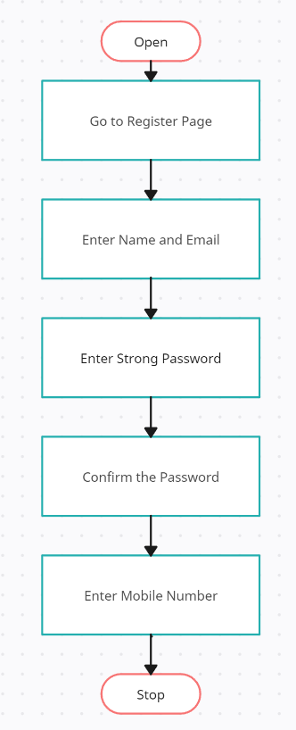

**3. Doctor Login**

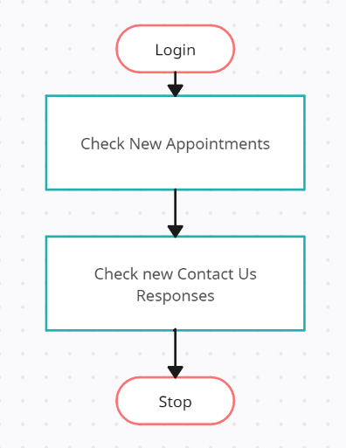

**4. User Login**



**5. Application Flow**

